A Handling Robot
- Description：

Among many industrial robots, handling robots are undoubtedly effective, applied in industrial manufacturing, warehousing and logistics, tobacco, medicine, food, chemical and other industries, or in post offices, libraries, ports and parking lots. In this experiment, we will use LEGO blocks to build a handling robot to carry things.

- How to build up a handling robot
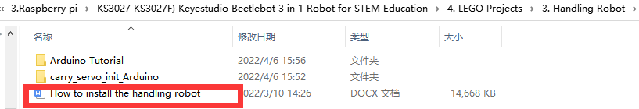

- Test Code：
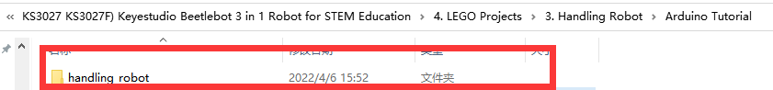

Connect Wifi, click buttons to make the car to move toward building blocks and put some building blocks on the robot.
Then press to drive the robot to move.

Hold down the button to drive the robot to drop building blocks, then building blocks can be conveyed

